**Image 1: Homepage**

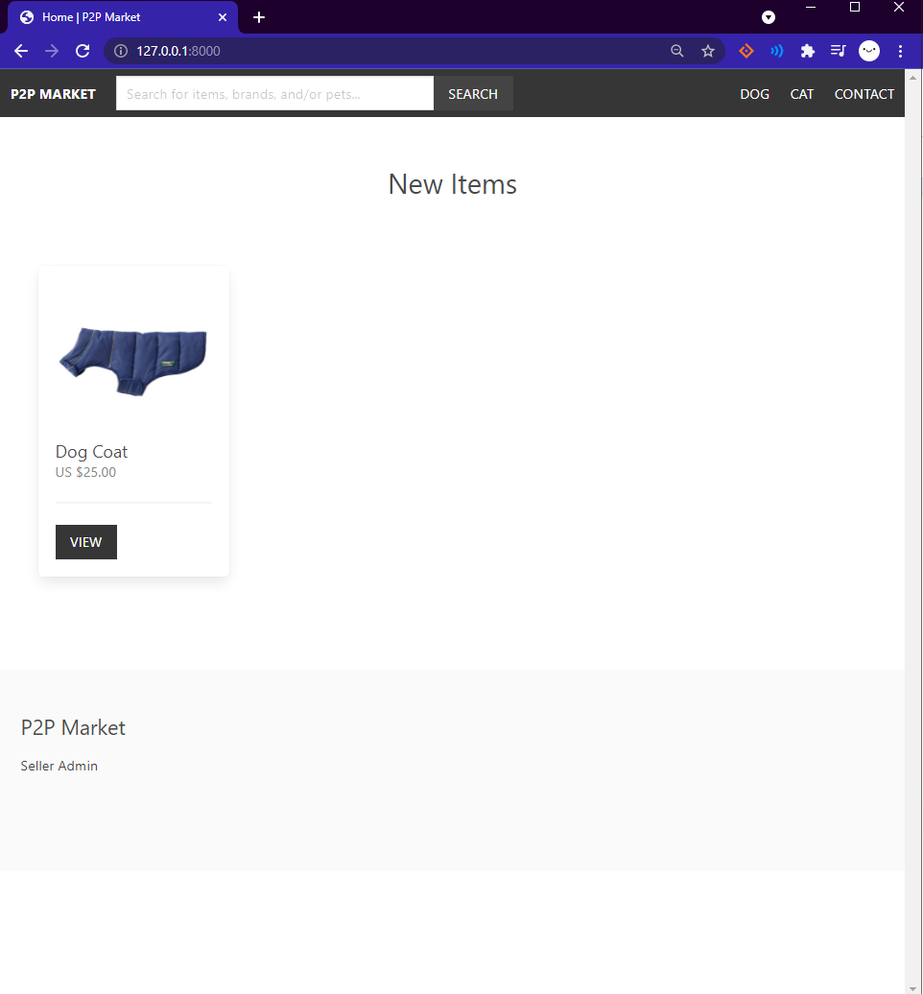

**Key Points:**

* Top left leads to homepage
* Search bar
* First categories tested but will be in a navigation format
* Will populate local database, but didn’t want to freeze computer
* Can click on view to take to item page
* Bottom is seller Admin page/Or Become a Seller if you don't have a account

**Image 2: Seller Sign Up Page**

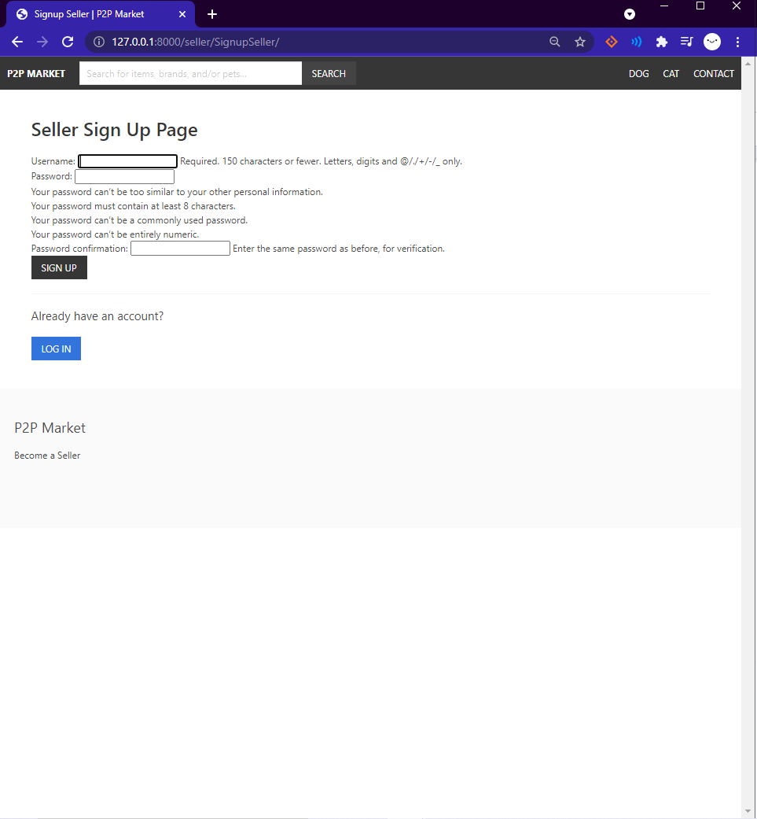

**Key Points:**

* Bottom Left shows the Become a seller if you aren’t one
* Sign up page
* If you have account you can login

**Image 3: Login Page**

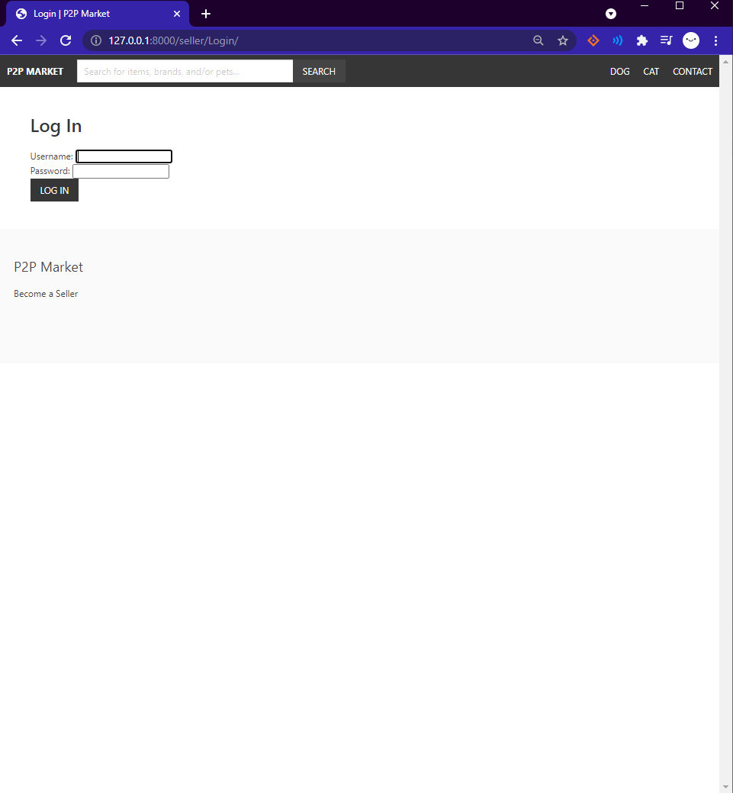

**Key Points:**

* Login for user
* Username or email
* If you have account you can login

**Image 4: Seller Admin Page**

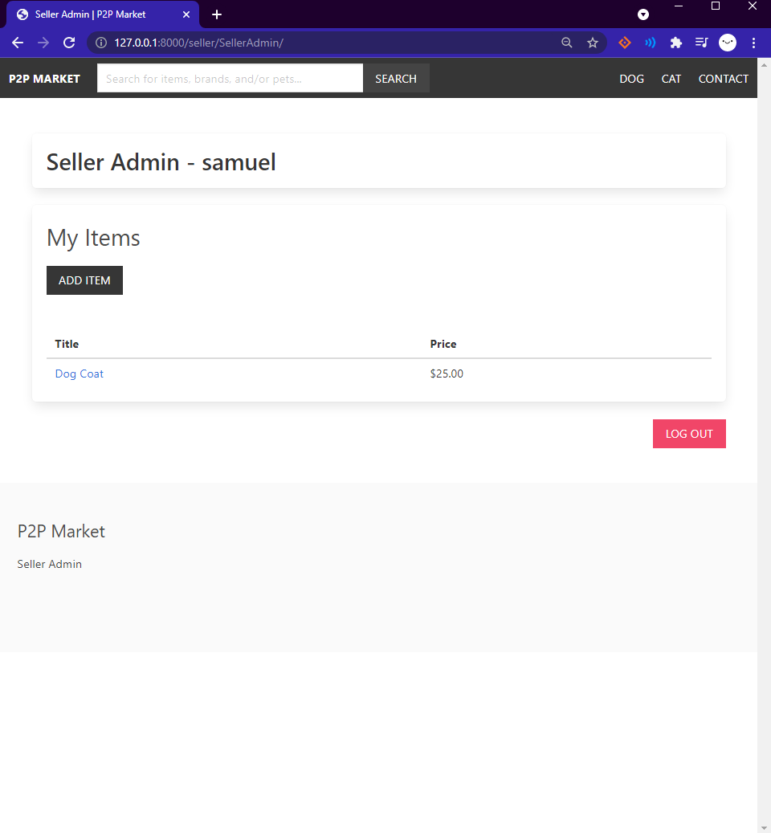

**Key Points:**

* Seller admin shows user name ie. samuel
* Shows item Given its title and price
* Allows to add item
* Logout of your user page

**Image 5: Add Item Page**

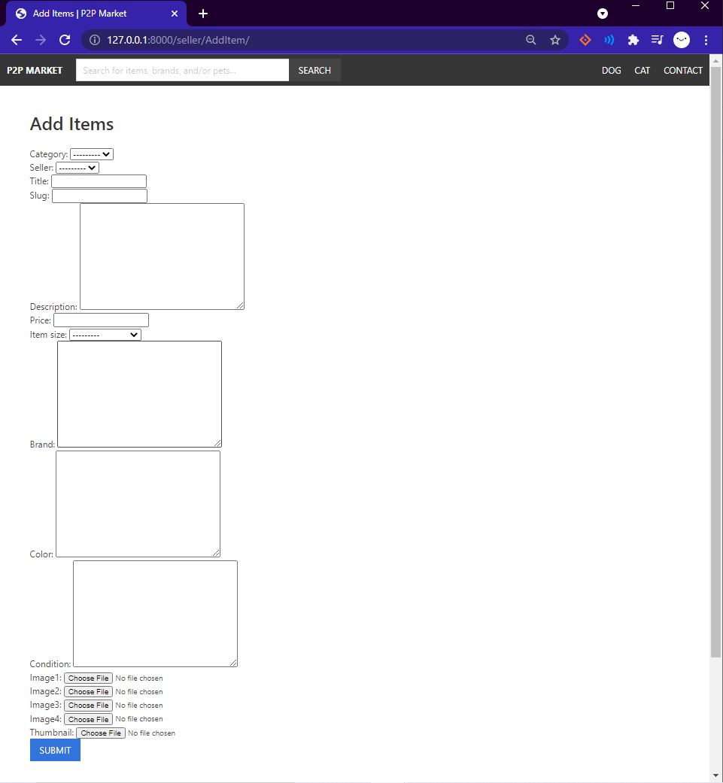

**Key Points:**

* Listing the available required elements from the Model(database) of allowed data entries
* Submit sends to admin page

**Image 5: Item Page**

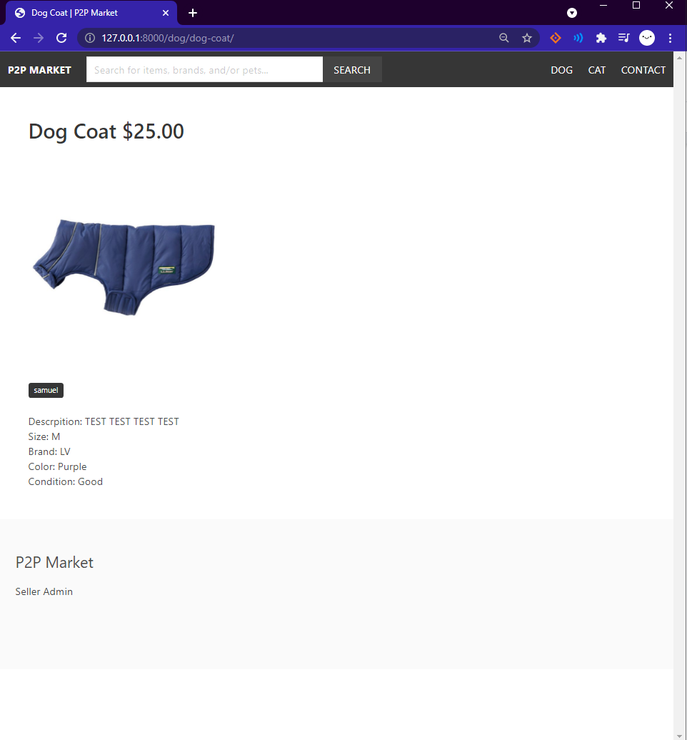

**Key Points:**

* Item shows the seller and all the data entries from the seller
* Will have implementation for cart
* Will make a way to have more than one image with proper html formatting

**Image 5: Search**

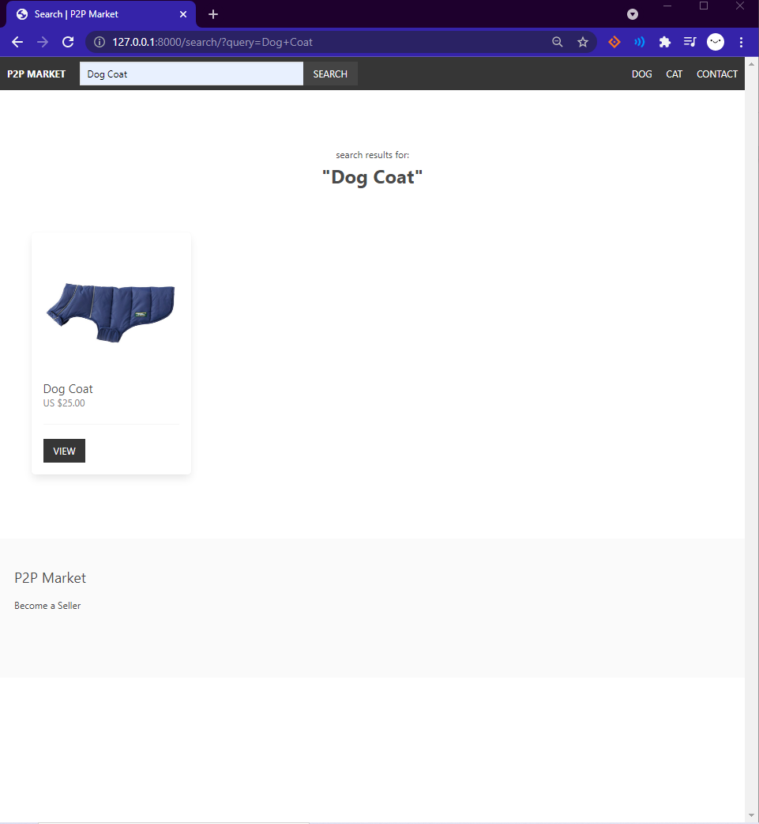

**Key Points:**

* Search for items or any item corresponding to the data entries and/or title of the item